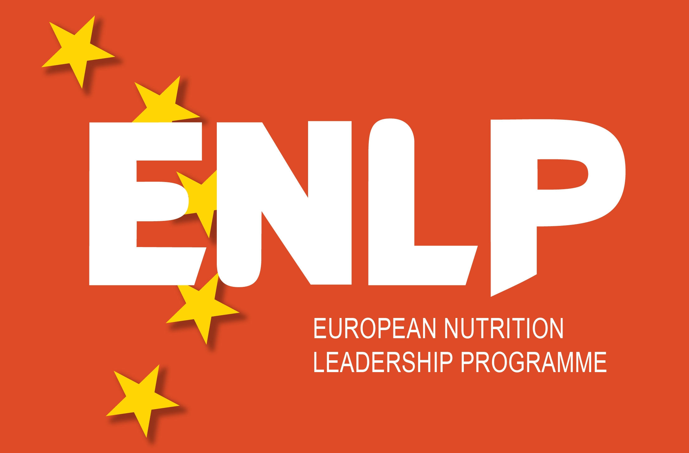

18th Seminar European Nutrition Leadership Programme, Luxembourg

(Arrival 28 March – 5 April Departure)

Course directors: Professor Renger Witkamp, PhD and Karin van het Hof, PhD

Application Form

Return to: Mrs L.A. Duym-Brookman,
Division of Human Nutrition, Wageningen University,
P.O. Box 8129, 6700 EV Wageningen, The Netherlands

Tel.: +31 317 483054 or 482589, Fax: +31 317 483342
Email: lous.duym@wur.nl

General information

The aim of the programme is to assist in the development of future leaders in the field of human nutrition in Europe. The first seminar was held in 1994. Emphasis is given to understanding the qualities and skills of leaders, team building, communication of nutrition information in a broader context, and to understanding the role of nutrition science in society. The participants of the 2003 seminar aptly expressed the vision of the seminars as follows: ‘To provide a European platform where young nutritionists meet in harmony, realise their potential and leave as leaders’. Seminars have been held annually since 1994, except in 1999.
These seminars are not focused on science, but on other skills and behavioural competencies, which future leaders need to have. Therefore, professional trainers in team building, communication and leadership are invited to lecture and discuss individual skills and competencies. The programme is organised by a group of leading European nutritionists in close collaboration with and funded by the European food industry and a consortium of European universities and research institutes (ENABLE).

The programme is designed for ambitious final year PhD students and postdoctoral fellows or early-stage researchers in human nutrition science in Europe. Nutrition professionals with an MSc or PhD degree in nutrition or related sciences, who have several years of professional experience in the area of food/nutrition and health, are also invited to apply. Applications are welcome especially from countries which have been under-represented until now, e.g. the new EU member states in Eastern and Central Europe and to a lesser extent the southern European countries.
Preference will be given to candidates under the age of 35 years. Thirty candidates will be selected by an independent international selection committee to attend the seminar.

Applications should be received at the ENLP secretariat at the latest on 30 November 2011. Candidates will be informed of the decision of the selection committee by mid January 2012.
The application form is also available on the internet at: www.enlp.eu.com



- Name and first name(s):
Sex, date of birth:
Nationality and, if applicable, residence status:

- Present position (full-time PhD fellow/employed while working part-time towards a PhD degree/post-doctoral fellow/Nutrition professional/other, please specify):

- Address at work (include postal code, city and country):

Telephone number: Telefax number:
Email:

- Address at home (include telephone number and also email if different from above):

- University degree(s) or other than PhD (including title of degree granted, university and faculty, years of study, year degree granted):

- PhD training:
University/institute of PhD training:
Year/month of start: Year/month of finish:
Topic of PhD research: (In Appendix 1, enclose a one-page summary of your PhD research programme including title, aims, achievements, papers accepted and/or published, and details of funding. If you have completed your PhD and are now carrying out different work, summarize such work on one page in Appendix 2).
Supervisor(s) (Provide names, address, telephone, fax and email address of each supervisor):

7. Other relevant work experience:

8. Knowledge of languages: speaking, reading, writing (fluent, good, moderate, poor)
Native language:
English:
Other:

9. Membership of scientific societies:

10. International experience related to your professional work:

11. How do you envisage your future career? What are your ambitions! (max 300 words)

12. Describe your reasons for applying to attend this seminar of the European Nutrition Leadership Programme (max 200 words):

13. Letters of recommendation: Please provide two letters of recommendation (not more). At least one of those letters should be from someone outside your institute/organization, most preferably from another country than your home country or the country where you are currently employed. Please enclose the letters of recommendation in a sealed envelope with your application or have them sent by post or email directly to the ENLP secretariat.

14. How did you learn about this programme?

15. Seminar fee: The fee for attending the seminar is € 1500. This includes full board and lodging from the
evening of 28 March to the morning of 5 April 2012 at the seminar hotel. Travel, insurance and personal
costs such as drinks and phone calls are not included.
ENLP support grants for participants:
ENLP has some funding available to support participants who are unable to obtain travel and/or participation fees from their employer or other sources. Decisions about grants are made by the Organizing Committee on the basis of the information supplied by the applicant and the ENLP rules on the grant/fund. The decision of the Organizing Committee is final.
Requests for grants/funds must be made in a separate accompanying letter with a budget and clear reasons given for the request.

The following options for grants exist:
Travel grant: Maximum amount of Euro 500 towards travel expenses which will only be paid on inspection of the relevant tickets.
Support grant: Maximum amount of Euro 450 towards payment of the participation fee. Please provide proof when it is not possible to pay the full fee.
Hardship fund: ENLP’s ambition is to have participants from all over Europe. In certain countries (especially the countries that recently became EU-members and the countries that are negotiating their EU-membership) conditions in Academia may prevent participation of suitable candidates. A limited number of grants covering the total expense of the ENLP-course are available for these candidates. Eligible persons should submit a request with clear argumentation and a letter of support from their supervisor together with their application.

Signature: Date:

